Assignment 1: Consumer Segmentation using PCA
Maxine Humphrey
Spring B 2026, MKT 472

Overview
A pilot survey was conducted of 30 individuals to understand their different attitudes towards discount stores (e.g., K-Mart), which usually come with low levels of service versus departmental stores (e.g., Macys) which come with higher levels of service. Respondents were asked their opinion on a 0-9 agree-disagree scale (where 0 indicates strongly disagree and 9 indicates strongly agree) on the following questions.
The data for this study are provided in assg1.csv Using this data, answer the following questions.

Questions

Instructions
install.packages("tidyverse", repos = "https://cloud.r-project.org")
## Installing package into 'C:/Users/mah64/AppData/Local/R/win-library/4.5'
## (as 'lib' is unspecified)
## package 'tidyverse' successfully unpacked and MD5 sums checked
##
## The downloaded binary packages are in
## C:\Users\mah64\AppData\Local\Temp\RtmpSIuj60\downloaded_packages
install.packages("corrplot", repos = "https://cloud.r-project.org")
## Installing package into 'C:/Users/mah64/AppData/Local/R/win-library/4.5'
## (as 'lib' is unspecified)
## package 'corrplot' successfully unpacked and MD5 sums checked
##
## The downloaded binary packages are in
## C:\Users\mah64\AppData\Local\Temp\RtmpSIuj60\downloaded_packages
library(tidyverse)
## ── Attaching core tidyverse packages ──────────────────────── tidyverse 2.0.0 ──
## ✔ dplyr 1.2.0 ✔ readr 2.2.0
## ✔ forcats 1.0.1 ✔ stringr 1.6.0
## ✔ ggplot2 4.0.2 ✔ tibble 3.3.1
## ✔ lubridate 1.9.5 ✔ tidyr 1.3.2
## ✔ purrr 1.2.1
## ── Conflicts ────────────────────────────────────────── tidyverse_conflicts() ──
## ✖ dplyr::filter() masks stats::filter()
## ✖ dplyr::lag() masks stats::lag()
## ℹ Use the conflicted package (<http://conflicted.r-lib.org/>) to force all conflicts to become errors
library(corrplot)
## corrplot 0.95 loaded
# Import the dataset
assg1 <- read.csv("assg1.csv")
# View the data
head(assg1)
## Resp X1 X2 X3 X4 X5
## 1 1 6 0 8 4 4
## 2 2 4 9 2 8 9
## 3 3 2 8 2 6 9
## 4 4 5 7 3 9 6
## 5 5 3 8 3 9 6
## 6 6 0 6 0 2 1
str(assg1)
## 'data.frame': 30 obs. of 6 variables:
## $ Resp: int 1 2 3 4 5 6 7 8 9 10 ...
## $ X1 : int 6 4 2 5 3 0 1 7 7 7 ...
## $ X2 : int 0 9 8 7 8 6 9 2 0 4 ...
## $ X3 : int 8 2 2 3 3 0 2 6 9 5 ...
## $ X4 : int 4 8 6 9 9 2 7 6 2 8 ...
## $ X5 : int 4 9 9 6 6 1 9 4 2 2 ...
#Question 1
# Select the five variables used in PCA
X <- assg1 %>% select(X1, X2, X3, X4, X5)
# Summary of original data
summary(X)
## X1 X2 X3 X4 X5
## Min. :0.0 Min. :0.000 Min. :0.000 Min. :0.0 Min. :0.000
## 1st Qu.:2.0 1st Qu.:2.500 1st Qu.:2.000 1st Qu.:2.5 1st Qu.:2.000
## Median :5.0 Median :6.000 Median :3.000 Median :6.0 Median :4.000
## Mean :4.4 Mean :5.133 Mean :3.667 Mean :5.4 Mean :4.533
## 3rd Qu.:7.0 3rd Qu.:7.750 3rd Qu.:5.750 3rd Qu.:8.0 3rd Qu.:6.000
## Max. :9.0 Max. :9.000 Max. :9.000 Max. :9.0 Max. :9.000
# Means and standard deviations of original variables
sapply(X, mean)
## X1 X2 X3 X4 X5
## 4.400000 5.133333 3.666667 5.400000 4.533333
sapply(X, sd)
## X1 X2 X3 X4 X5
## 2.943139 3.059562 2.745948 2.907778 2.849481
# Scale the data
X_scaled <- scale(X)
# Summary of scaled data
summary(X_scaled)
## X1 X2 X3 X4
## Min. :-1.4950 Min. :-1.6778 Min. :-1.3353 Min. :-1.8571
## 1st Qu.:-0.8155 1st Qu.:-0.8607 1st Qu.:-0.6070 1st Qu.:-0.9973
## Median : 0.2039 Median : 0.2833 Median :-0.2428 Median : 0.2063
## Mean : 0.0000 Mean : 0.0000 Mean : 0.0000 Mean : 0.0000
## 3rd Qu.: 0.8834 3rd Qu.: 0.8552 3rd Qu.: 0.7587 3rd Qu.: 0.8942
## Max. : 1.5630 Max. : 1.2638 Max. : 1.9423 Max. : 1.2381
## X5
## Min. :-1.5909
## 1st Qu.:-0.8891
## Median :-0.1872
## Mean : 0.0000
## 3rd Qu.: 0.5147
## Max. : 1.5675
The dataset contains 30 respondents and 5 shopping attitude variables (X1 through X5). Since PCA is sensitive to the scale of the variables, I standardized the data before performing the analysis. After scaling, each variable has mean approximately 0 and standard deviation approximately 1, making the variables comparable for PCA.
#Question 2
# Correlation matrix
cor_mat <- cor(X)
round(cor_mat, 3)
## X1 X2 X3 X4 X5
## X1 1.000 -0.711 0.879 0.343 -0.039
## X2 -0.711 1.000 -0.832 0.257 0.470
## X3 0.879 -0.832 1.000 0.173 -0.021
## X4 0.343 0.257 0.173 1.000 0.664
## X5 -0.039 0.470 -0.021 0.664 1.000
# Correlation plot
corrplot(cor_mat,
method = "circle",
type = "upper",
addCoef.col = "black",
tl.col = "black",
tl.srt = 45)
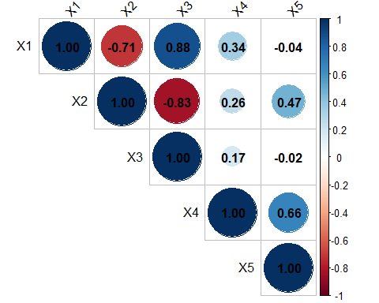
The correlation matrix shows several strong relationships among the variables.
X1 and X3 are strongly positively correlated, suggesting that consumers who dislike being treated disrespectfully also tend to appreciate salespeople who answer their questions. X1 and X2 are strongly negatively correlated, meaning consumers who value respectful service are less likely to think attentive salespeople are irritating. X2 and X3 are also negatively correlated, indicating that people who dislike attention from salespeople are also less likely to want detailed help from them. X4 and X5 are positively correlated, suggesting that consumers who do not care for department store displays are more likely to believe discount stores offer better bargains.
These patterns suggest that the variables may reflect two broader dimensions: one related to service expectations and another related to discount or value orientation.
#Question 3
# Run PCA using standardized variables
pca_fit <- prcomp(X, scale. = TRUE)
# PCA summary
summary(pca_fit)
## Importance of components:
## PC1 PC2 PC3 PC4 PC5
## Standard deviation 1.6345 1.3610 0.58478 0.30601 0.20148
## Proportion of Variance 0.5343 0.3704 0.06839 0.01873 0.00812
## Cumulative Proportion 0.5343 0.9048 0.97315 0.99188 1.00000
# Eigenvalues and variance explained
eigenvalues <- pca_fit$sdev^2
prop_var <- eigenvalues / sum(eigenvalues)
cum_var <- cumsum(prop_var)
pca_results <- data.frame(
Component = paste0("PC", 1:length(eigenvalues)),
Eigenvalue = eigenvalues,
Proportion_Variance = prop_var,
Cumulative_Variance = cum_var
)
knitr::kable(pca_results, digits = 3)
Component | Eigenvalue | Proportion_Variance | Cumulative_Variance
PC1 | 2.672 | 0.534 | 0.534
PC2 | 1.852 | 0.370 | 0.905
PC3 | 0.342 | 0.068 | 0.973
PC4 | 0.094 | 0.019 | 0.992
PC5 | 0.041 | 0.008 | 1.000
# Rotation matrix (loadings)
round(pca_fit$rotation, 3)
## PC1 PC2 PC3 PC4 PC5
## X1 -0.555 0.232 -0.280 -0.723 0.191
## X2 0.571 0.212 -0.183 -0.462 -0.618
## X3 -0.580 0.157 0.311 0.187 -0.713
## X4 -0.017 0.686 -0.561 0.461 0.041
## X5 0.174 0.637 0.691 -0.125 0.267
# Correlation between original variables and principal components
factor_cor <- cor(X, pca_fit$x)
round(factor_cor, 3)
## PC1 PC2 PC3 PC4 PC5
## X1 -0.907 0.316 -0.163 -0.221 0.039
## X2 0.933 0.288 -0.107 -0.141 -0.125
## X3 -0.947 0.213 0.182 0.057 -0.144
## X4 -0.028 0.934 -0.328 0.141 0.008
## X5 0.284 0.867 0.404 -0.038 0.054
The PCA results show that the first two principal components explain most of the variation in the data.
PC1 explains about 53.4% of the variance. PC2 explains about 37.0% of the variance. Together, PC1 and PC2 explain about 90.5% of the total variance.
This means that the five original variables can be summarized very well using just two components. The loading and correlation matrices show that PC1 is mostly associated with service-related attitudes, while PC2 is mainly associated with discount and value-related attitudes.
#Question 4
round(pca_fit$rotation, 3)
## PC1 PC2 PC3 PC4 PC5
## X1 -0.555 0.232 -0.280 -0.723 0.191
## X2 0.571 0.212 -0.183 -0.462 -0.618
## X3 -0.580 0.157 0.311 0.187 -0.713
## X4 -0.017 0.686 -0.561 0.461 0.041
## X5 0.174 0.637 0.691 -0.125 0.267
Using the PCA loading matrix, the five principal component equations are:
PC1=0.555X1−0.571X2+0.580X3+0.017X4−0.174X5
PC2=0.232X1+0.212X2+0.157X3+0.686X4+0.637X5
PC3=−0.280X1−0.183X2+0.311X3−0.561X4+0.691X5
PC4=0.723X1+0.462X2−0.187X3−0.461X4+0.125X5
PC5=−0.191X1+0.618X2+0.713X3−0.041X4−0.267X5
These equations show that each principal component is a weighted combination of the original shopping attitude variables.
#Question 5
# Scree plot
plot(eigenvalues, type = "b", pch = 19,
xlab = "Principal Component",
ylab = "Eigenvalue",
main = "Scree Plot")
abline(h = 1, col = "red", lty = 2)
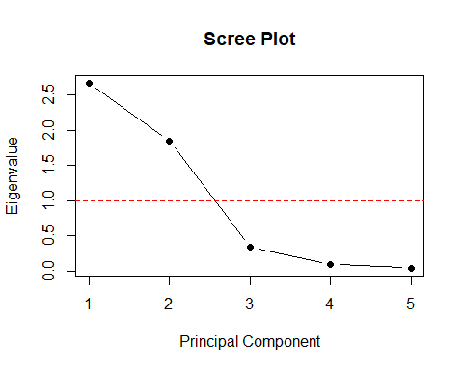 I would retain 2 principal components.
There are three reasons for this decision:
Kaiser criterion: Components with eigenvalues greater than 1 should be retained. Only PC1 and PC2 meet that rule. Cumulative variance explained: PC1 and PC2 together explain about 90.5% of the total variance, which is very high. Scree plot: There is a clear drop after the second component, and the remaining components contribute much less information.
Therefore, retaining 2 components is the most reasonable choice.
Question 6
The first principal component can be labeled Service Sensitivity or Service Expectation.
This factor is strongly associated with:
disliking disrespect in stores (X1) appreciating salespeople who answer questions (X3) not finding attentive salespeople irritating (X2, with opposite direction)
Consumers with high scores on this factor seem to care about respectful and helpful service.
The second principal component can be labeled Discount / Value Orientation.
This factor is strongly associated with:
not caring for fancy department store displays (X4) believing discount stores offer better bargains (X5)
Consumers with high scores on this factor appear to focus more on bargains and value than on the shopping environment.
#Question 7
# PCA scores
scores <- as.data.frame(pca_fit$x)
scores$Resp <- assg1$Resp
# Two-dimensional map
plot(scores$PC1, scores$PC2,
xlab = "Service Sensitivity",
ylab = "Discount / Value Orientation",
main = "Consumer Map Based on First Two Principal Components",
pch = 19)
text(scores$PC1, scores$PC2, labels = scores$Resp, pos = 3, cex = 0.8)
abline(h = 0, v = 0, lty = 2, col = "gray")
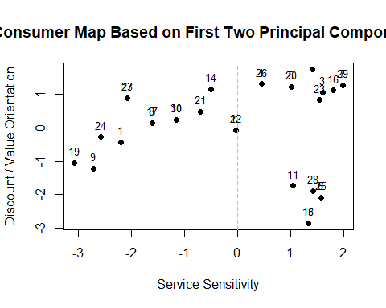
The two-dimensional map plots each consumer according to their position on the first two principal components. Consumers near each other on the plot have similar shopping attitudes, while consumers farther apart have more different preferences.
The x-axis represents service sensitivity, and the y-axis represents discount/value orientation.
# Question 8
# Optional clustering to support visual interpretation
set.seed(123)
km3 <- kmeans(scores[, c("PC1", "PC2")], centers = 3, nstart = 20)
scores$segment <- as.factor(km3$cluster)
plot(scores$PC1, scores$PC2,
col = scores$segment,
pch = 19,
xlab = "Service Sensitivity",
ylab = "Discount / Value Orientation",
main = "Consumer Segments on PCA Map")
text(scores$PC1, scores$PC2, labels = scores$Resp, pos = 3, cex = 0.8)
abline(h = 0, v = 0, lty = 2, col = "gray")
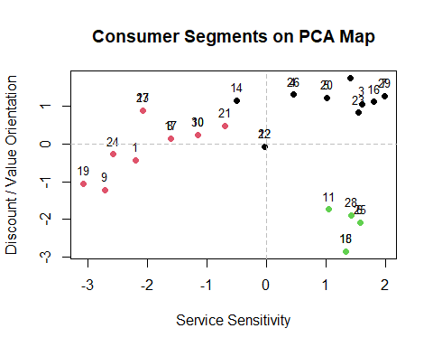 Based on the PCA map, the market appears to contain about 3 segments.
Visually, the consumers seem to group into:
a service-oriented group, a bargain/value-oriented group, and a group that is less service-driven and less discount-focused.
The k-means clustering with 3 centers supports this rough segmentation.
#Question 9
# Add segment labels back to original data
assg1$segment <- km3$cluster
# Segment means for original variables
segment_profile <- assg1 %>%
group_by(segment) %>%
summarise(across(X1:X5, mean))
segment_profile
## # A tibble: 3 × 6
## segment X1 X2 X3 X4 X5
## <int> <dbl> <dbl> <dbl> <dbl> <dbl>
## 1 1 3.62 7.62 2.62 7.23 7
## 2 2 7.36 1.73 6.73 5.64 3.55
## 3 3 0.667 6 0.333 1 1
The segment profiles can be interpreted as follows:
Segment 1: Service-Oriented Shoppers
These consumers score high on the service factor. They:
dislike disrespect in stores, value salespeople who answer questions, are less likely to be irritated by salesperson attention.
This group appears to prefer a more helpful and service-focused shopping environment.
Segment 2: Discount / Bargain Seekers
These consumers score high on the discount/value factor. They:
do not care much about department store displays, are more likely to believe discount stores offer better bargains, tend to be more focused on value than service.
This group appears most attracted to discount-oriented retail settings.
Segment 3: Independent Department-Store Shoppers
These consumers are lower on both service sensitivity and discount orientation. They:
are not strongly attracted to discount stores, may value the department store environment, but do not especially want a lot of salesperson interaction.
This group seems to prefer a more independent shopping experience in a traditional retail setting.
These segment descriptions connect back directly to the original variables because the PCA factors were formed from those five attitude measures.
#Question 10
# Segment sizes
segment_sizes <- assg1 %>%
count(segment) %>%
mutate(percent = 100 * n / sum(n))
segment_sizes
## segment n percent
## 1 1 13 43.33333
## 2 2 11 36.66667
## 3 3 6 20.00000
The segment I would expect to be the most profitable is the Independent Department-Store Shoppers segment.
This segment is likely to be the most profitable because:
they do not appear highly price-sensitive, they are less attracted to discount stores, they may be willing to shop in higher-margin department store environments, and they do not seem to require as much sales assistance as the highly service-oriented group.
That combination suggests higher revenue potential with lower service cost.
Using the segment size table, the size of this segment can be calculated as:

Segment Size
Number of Consumers in Segment 30 × 100 Segment Size= 30 Number of Consumers in Segment ​
×100
If this segment contains 6 consumers, then its size is:
6 30 × 100 = 20 % 30 6 ​
×100=20%
So the estimated size of the most profitable segment would be 20% of the market.
Conclusion
The PCA results show that consumer shopping attitudes can be summarized using two main dimensions: Service Sensitivity and Discount / Value Orientation. These two factors explain over 90% of the variation in the data, making them very useful for understanding consumer behavior.
Based on the PCA map, the market appears to contain about three consumer segments: service-oriented shoppers, bargain seekers, and independent department-store shoppers. Among these, the independent department-store shoppers may be the most profitable because they appear less price-sensitive while also requiring less sales support.

